Systematically analyzing task decompositions with Tareador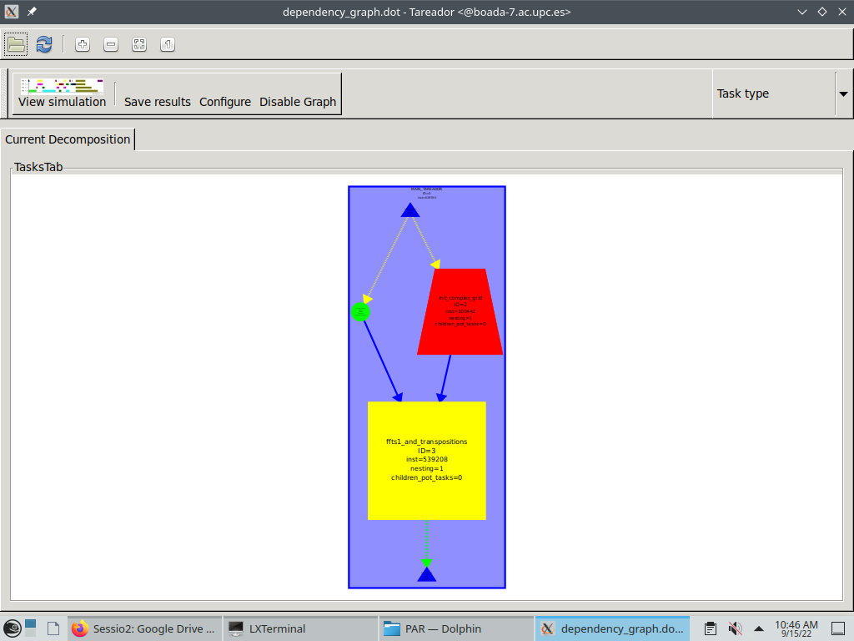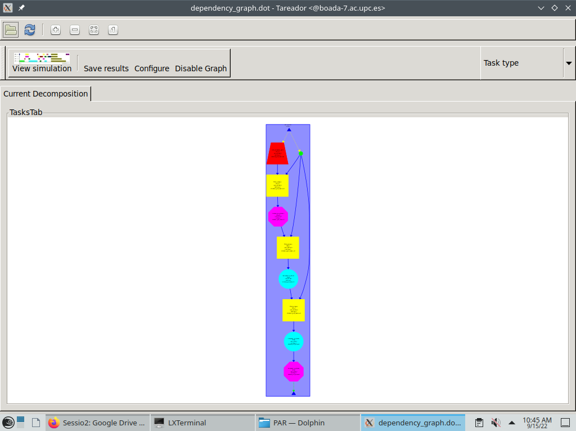

<-3dfft_tarV0 3dfft_tarv1->

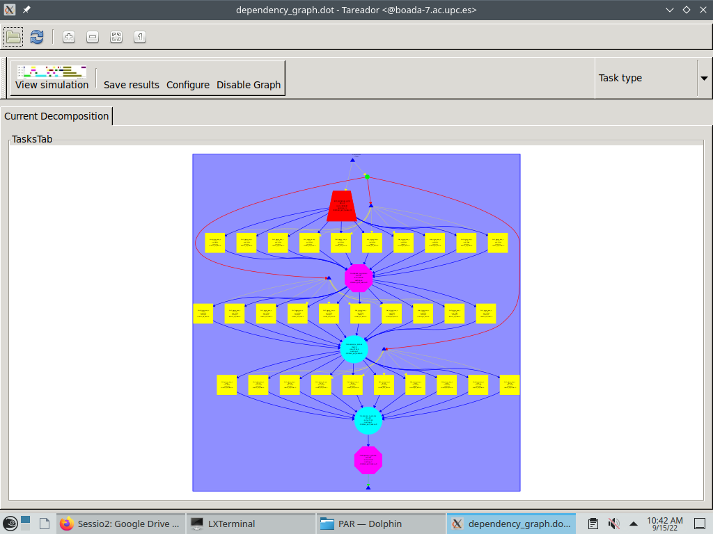

3dfft_tarV2

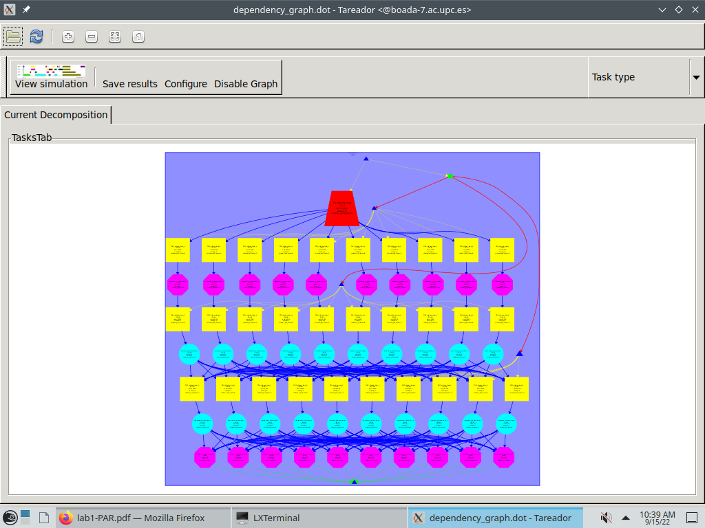

3dfft_tarV3

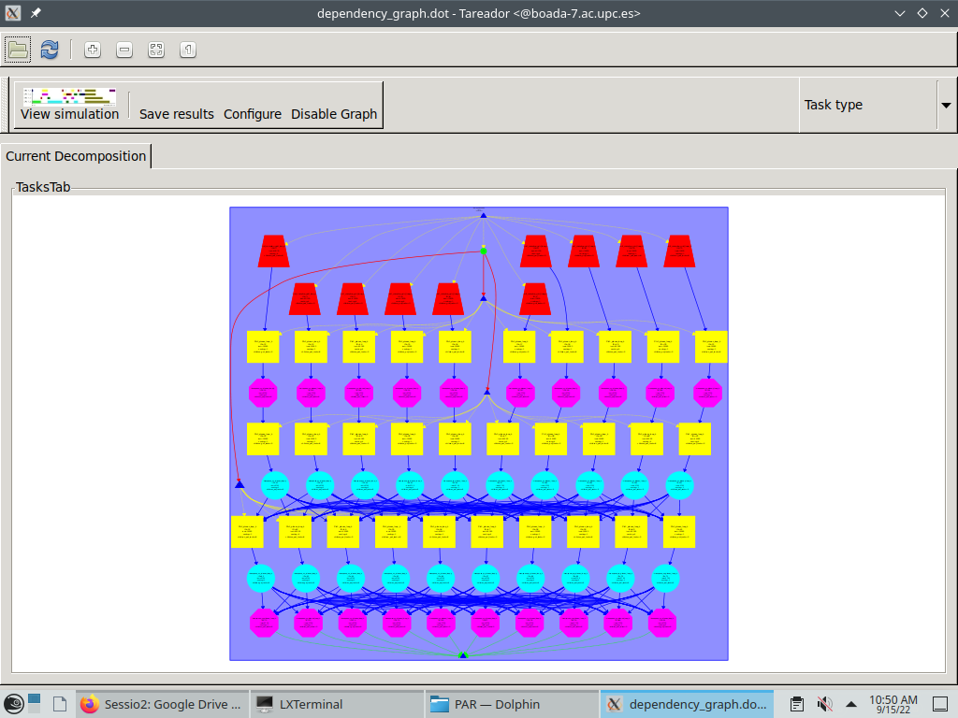

3dfft_tarV4

3dfft_tarV5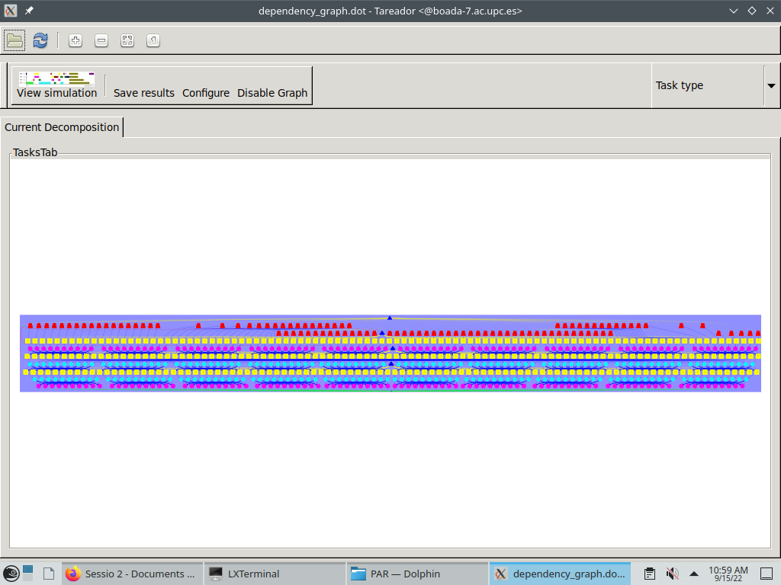

Execution table

| Version | T1 | T∞ | Parallelism |
| --- | --- | --- | --- |
| seq | 0.64 | 0.64 | 1 |
| v1 | 0.64 | 0.64 | 1 |
| v2 | 0.64 | 0.36 | 1.78 |
| v3 | 0.64 | 0.15 | 4.27 |
| v4 | 0.64 | 0.06 | 10.67 |
| v5 | 0.64 | 0.01 | 64 |

Time table

| Threads Num | V4 | V4 Speed-up | V5 | V5 Speed-up |
| --- | --- | --- | --- | --- |
| 1 | 0.64 | 1 | 0.64 | 1 |
| 2 | 0.32 | 2 | 0.32 | 2 |
| 4 | 0.17 | 3.76 | 0.16 | 4 |
| 8 | 0.09 | 7.11 | 0.08 | 8 |
| 16 | 0.06 | 10.67 | 0.04 | 16 |
| 32 | 0.06 | 10.67 | 0.02 | 32 |
| 128 | 0.06 | 10.67 | 0.01 | 64 |

V4 CODI RELLEVANT

…

for (k=0; k<N; k++) {

tareador_start_task("transpose_xy_planes_loop_k");

for (j=0; j<N; j++) {

for (i=0; i<N; i++) {

tmp_fftw[k][i][j][0] = in_fftw[k][j][i][0];

tmp_fftw[k][i][j][1] = in_fftw[k][j][i][1];

}

}

tareador_end_task("transpose_xy_planes_loop_k");

}

…

CODI V5

void transpose_xy_planes(fftwf_complex tmp_fftw[][N][N], fftwf_complex in_fftw[][N][N]) {

int k,j,i;

for (k=0; k<N; k++) {

for (j=0; j<N; j++) {

tareador_start_task("transpose_xy_planes_loop_j");

for (i=0; i<N; i++)

{

tmp_fftw[k][i][j][0] = in_fftw[k][j][i][0];

tmp_fftw[k][i][j][1] = in_fftw[k][j][i][1];

}

tareador_end_task("transpose_xy_planes_loop_j");

}

}

}